MONGO DB – 21/7/25 (installation & Practice)

Mongo db & Mongosh version

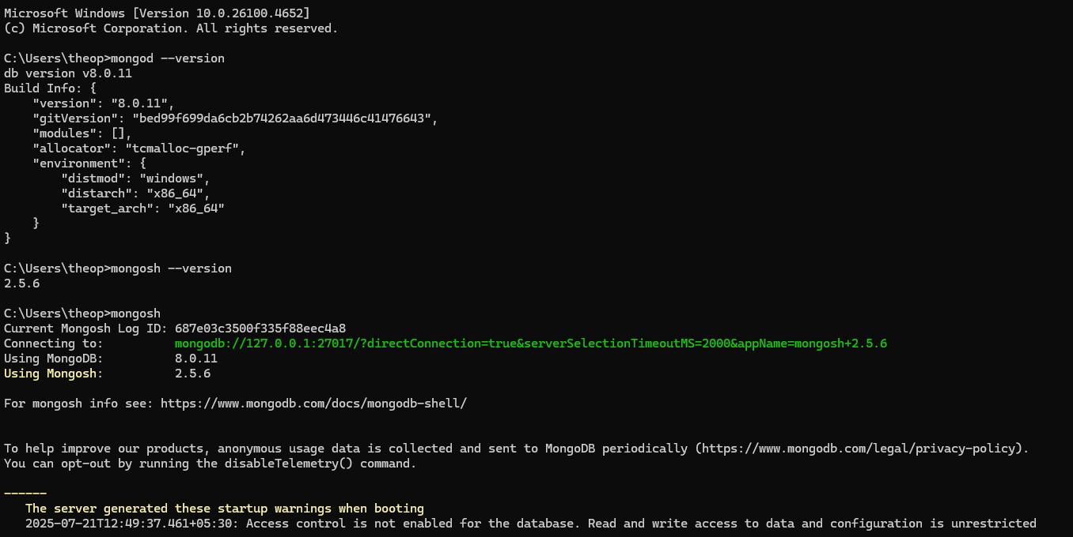

Collection(table) creation in MongoDB

Inserting One and Many Documents(rows & columns)

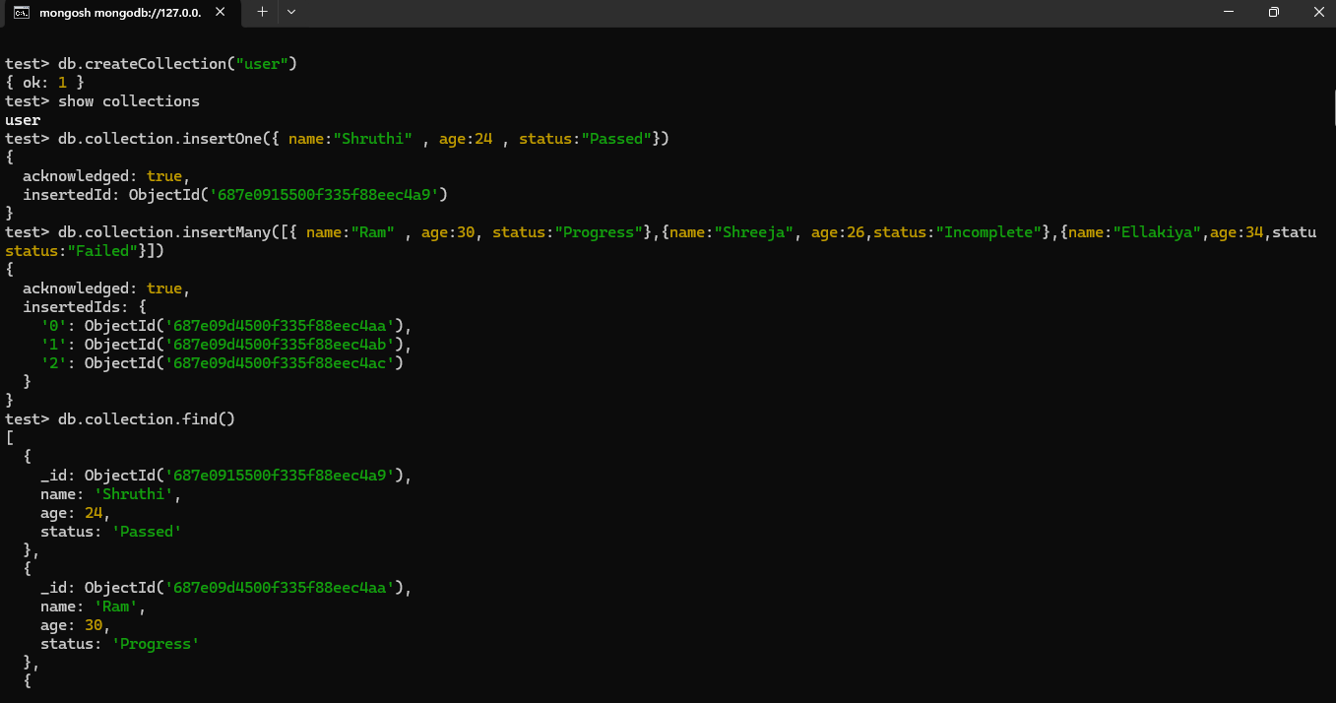

Find() & And(,) in MongDB

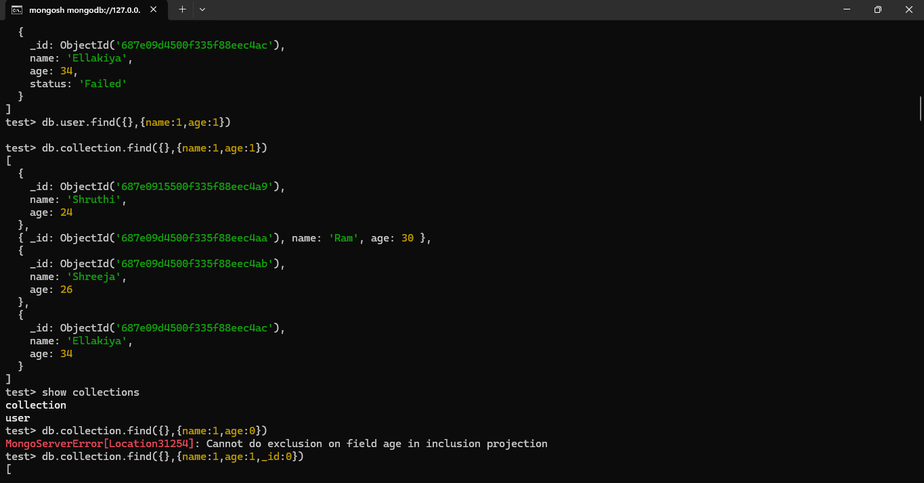

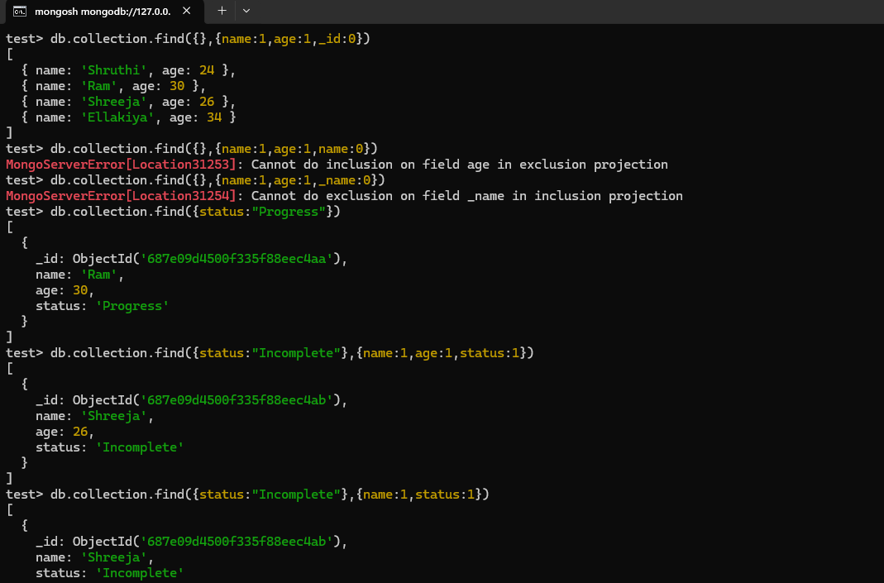

Find() & Not Equal to($ne) & Or ($or) in MongoDB

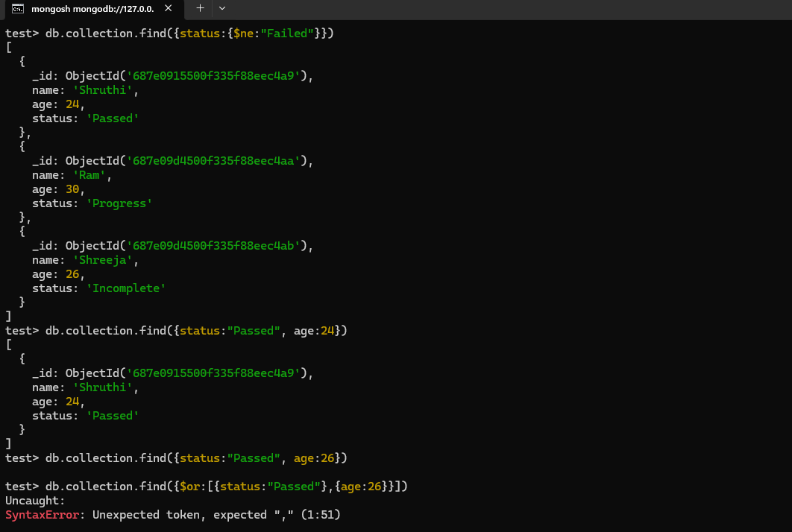

Find() & Greater Than($gt) in MongoDB

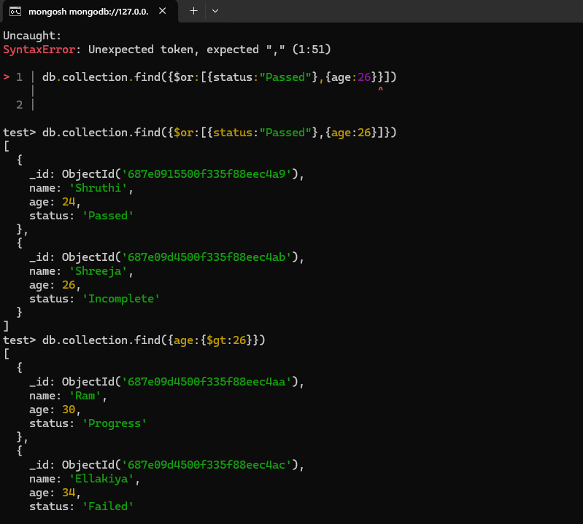

Find() & Less Than($lt) & Less Than Equal to($lte) in MongoDB

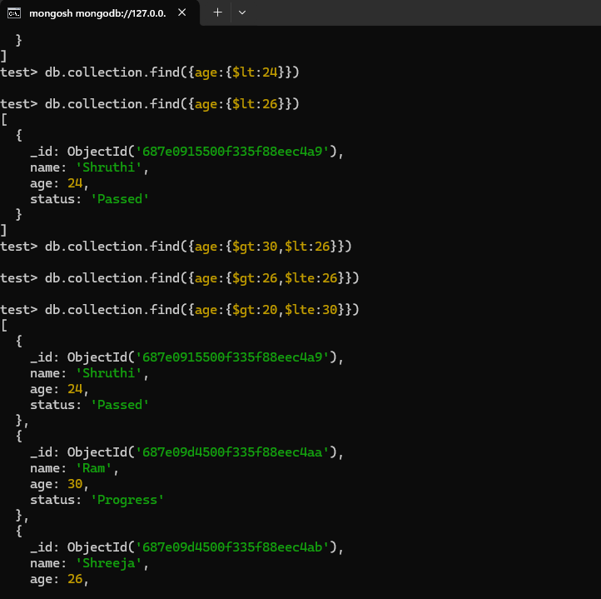

Find() & Like operator(/eg./) in MongoDB

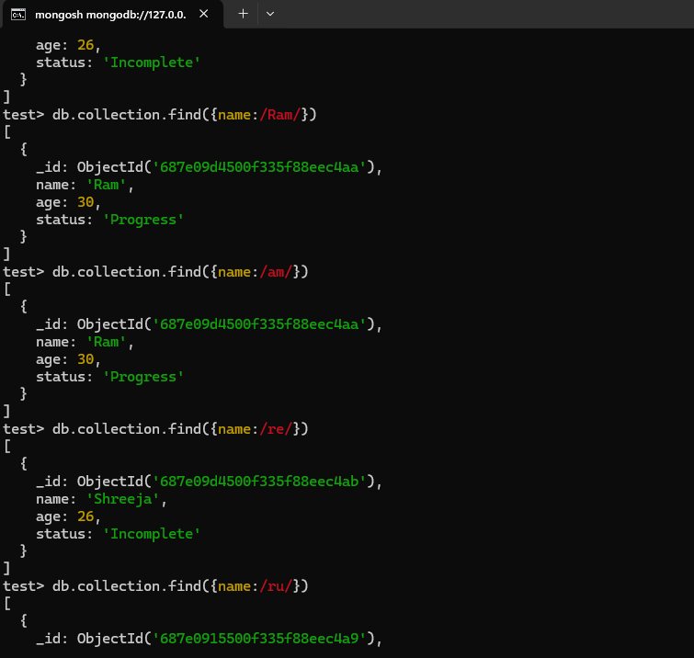

Find() & regex(/eg/) in MongoDB

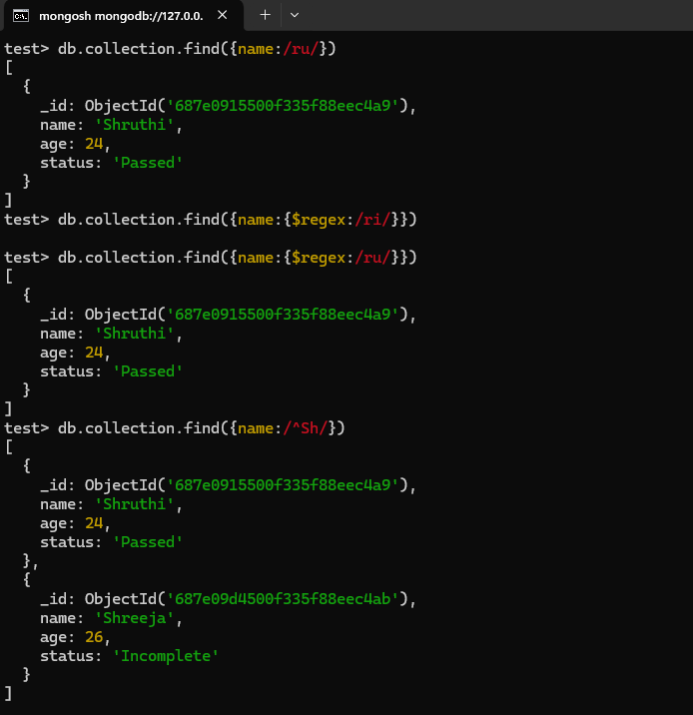

Find() & StartsWith(/^eg/) in MongoDB

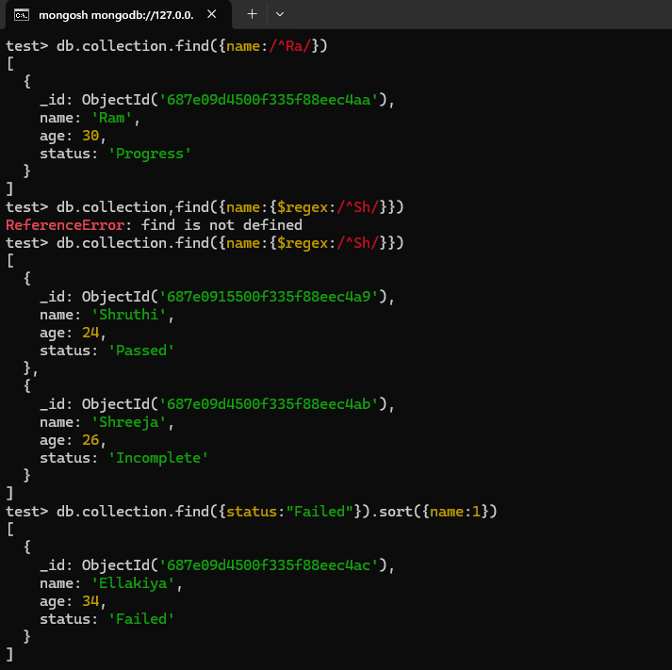

Find() & sort()

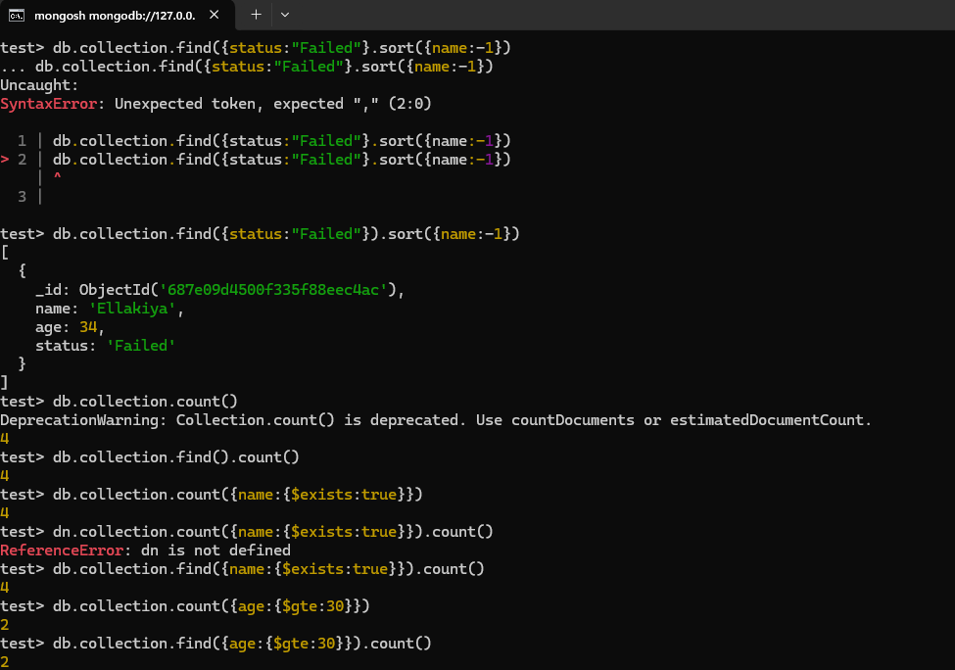

Find() & Distinct()

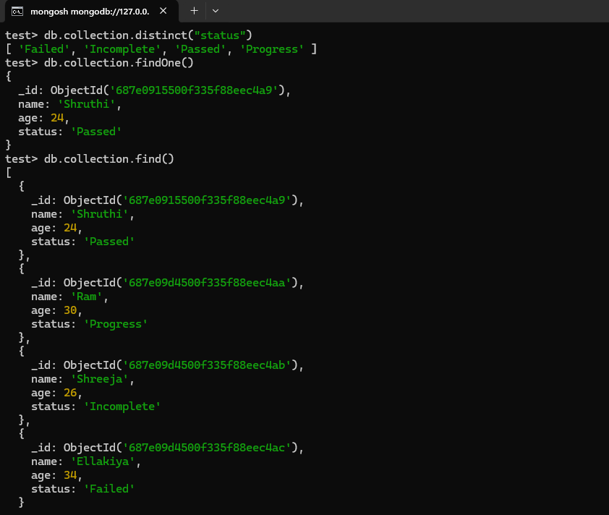

Limit() & Skip() in MongoDB

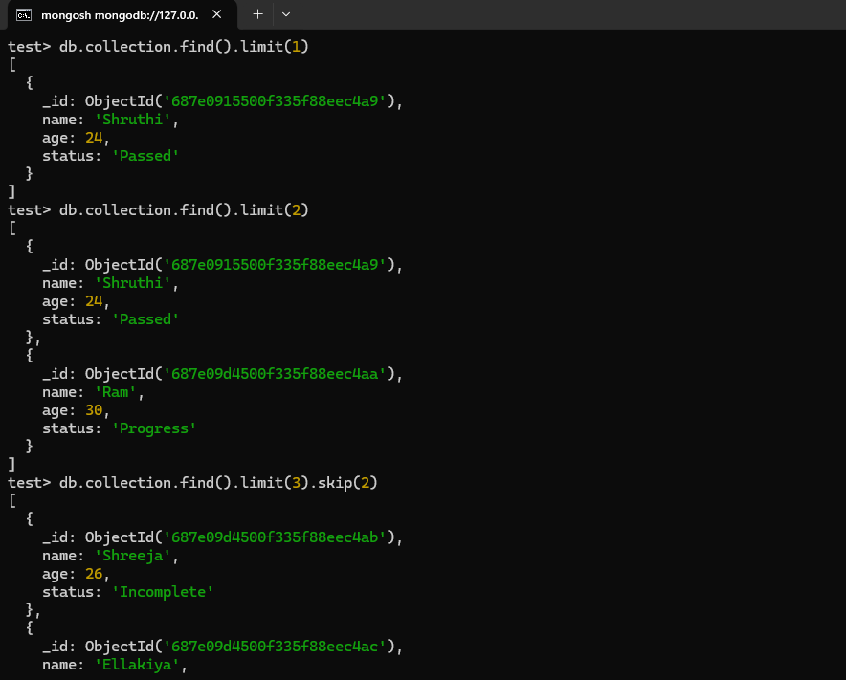

Explain() in MongoDB

